

**SEN 645: Software Project Management**

**Technical Paper**

A Public Learning Platform for Democratizing Higher Education

**Submitted by: Group 02**

**1 Introduction** **4**

**2 Literature Review** **5**

**3 Methodology** **7**

3.1 Designing Methodology 8

3.1.1 Rich Picture of Envisioned LMS 8

3.1.2 Process Diagrams 9

**4 Problem Statement** **9**

**5 Proposed Solution** **12**

**6 Feasibility Analysis** **15**

6.1 Economical Feasibility 15

6.2 Technical Feasibility 23

6.3 The Benefits 26

6.4 Quality Measurement 29

**7 Limitations and Constraints** **30**

**8 Conclusion** **30**

*This page is intentionally left blank.*

**Abstract**

In this era of globalization, it is very easy to share and disseminate knowledge due to the rapid evolution in technology. Information and communication technologies with their continuous development provide new possibilities for the creation of innovative and effective environments of teaching and learning, thus redefining the educational processes. Although e-learning has already been accepted globally as an effective medium of delivery of quality education and ensuring optimum student participation, Bangladeshi higher educational institutions are still at a very early stage of adopting such technologies. Therefore, the purpose of this paper is to critically examine the problems of the existing educational system as a whole, and to propose a feasible e-learning solution via a Government regulated learning management system (LMS) that could offer affordable and easy access to higher education. The benefits of implementing such a system is then discussed, with respect to the stakeholders involved in the proposed system. The paper also includes preliminary planning and analysis, and it ends by acknowledging the limitations of this study.

**Keywords**: e-Governance, Learning Management System, Software Engineering, System Analysis, Project Management, Proposal.

# **1 Introduction**

Over the next two decades, Bangladesh will experience an accelerated pace of change that will be rapid and transformational. It will have to cope with rapid transformational shifts in agriculture, trade, and industry, in education and healthcare, in transportation and communication, and in the way we work and conduct business.

As a young economy, Bangladesh is still a long way catching up to the standards of the global KE [Knowledge Economy]. According to the latest available (2012) ranking of the Knowledge Economy Index (KEI), Bangladesh was ranked at the low end of 137 out of 146 countries. Moreover, the vision of ‘Digital Bangladesh’ is not fulfilled yet. This suggested a long run ahead. While there are many long-term challenges in upgrading the KEI performance of Bangladesh, especially in the areas of spending on research and development and increasing the availability of skilled professionals in science and technology, Bangladesh has made important strides in the area of ICT. This is an area of strength for Bangladesh and an updated KEI performance review will likely see an increase in the Bangladesh rating.

Analytically, the [Knowledge Economy] can be defined as a process by which an economy produces, acquires, disseminates, and uses knowledge for serving the cause of development. A Knowledge Economy strategy comprises of policies and institutions that can be grouped into the following 3 dimensions:

1. Economic incentives and institutional arrangements to support the creation, acquisition, and conversion of edge into usable form based on research and innovations by public and private enterprises.
2. A body of skilled professionals in science and technology that can lead the research and innovation and adapt knowledge to the local circumstances.
3. An effective and efficient Information & Communications Technology (ICT) system that can disseminate knowledge and make it usable at the doorsteps of all citizens.

As a developing country Bangladesh needs to be prepared for the upcoming changes and the warriors will be the youth and they need to be equipped with adequate knowledge and skills to face the challenges of the 21st Century. A well equipped youth with technological know-how will contribute to fulfill the sustainable development goals. The knowledge and skills will contribute to the overall development of the country and the knowledge economy.

# **2 Literature Review**

The purpose of this literature review is to examine the adoption of the Learning Management System as an e-Government service in countries with developing economies. The day-to-day business of government is built on information. Information is a critical resource that helps to ensure the accountability of government, information about the eligible manpower enables governments to manage its operations more conveniently and allows the public to participate in the governance of their country. With the revolutionary changes that ICTs are bringing to our global society, governments worldwide continue to develop more sophisticated ways to digitize its routines and practices so that they can offer the public access to government services in more effective and efficient ways. Across the world, 173 of 190 countries use the Internet to deliver different government services. These activities are broadly referred to as digital government, which is an “umbrella term that comprises all uses of information and telecommunication technologies in the public sector” (Garson p. 18). e-Government focuses on the utilization of information and communication technologies (ICT) to deliver government services. e-Government is part of other closely related efforts in the digital government. This review demonstrates the importance and a sophisticated idea of implementing the Learning Management System as an e-service to support e-governance. e-Governance is understood as a set of activities involving the effective contribution of Information and Communication Technology (ICT) for strengthening administration and management in the higher education system. It can create transparency between colleges, universities, and students (Suklabaidya & Sen, 2013).

Learning Management Systems are used all around the world mostly for role-specific tasks and it offers a cloud-based training software that creates, manages, and tracks the learning initiatives of educational institutions and business organizations. Its in-built learning portals offer certificate courses, study modules, course calendars, video courses, training modules, and other E-learning materials in a platform containing advanced multilingual and encryption facilities. The multi-platform feature allows students, trainers, trainees, and co-administrators to enjoy anywhere-anytime learning with customized tests that come with automated email reports and learner analysis to further enrich the process. LMS software enables learner interaction through course discussion, sharing, and commenting. The gamification feature of these software comes with a rewards system that allows professionals and learners to earn personalized badges and access a leader board that tracks individual and collective milestones.

Different Organizations are providing LMS for Government Agencies too. There is no established Government LMS for providing higher education, to break the barrier between the universities and learners.

iLearn@QHealth is one of Queensland Health's Learning Management Systems (LMS). iLearn@QHealth currently hosts role-specific mandatory education and clinical education packages for the Department of Health and the Hospital and Health Services.

Higher education faces tough challenges in recent times due to the growing international demands. Seddiky (2015) stated that the present education system could not work effectively to meet the ever-evolving demands in today's competitive environment. Indeed, the whole education system is not updated and effective to face the challenges of electronic governance. The Modern world is now around with the idea of eGovernance and all countries want to go ahead with this concept to ensure development in a global context (Kumars, 2012). The use of e-Governance in educational management will benefit from analyzing the data accurately quickly, decision making provides the power to the administrators for efficient management of education and institution. e-Governance helps in improving transparency, dissemination, accountability, and public services in all aspects of education (Kapoor & Kelkar, 2013; Shrivastava et al., 2014). The purpose of implementing e-governance in any educational system will enable effective monitoring of academic standards and broaden innovations. Besides, it will help for the betterment of higher education in the country and increase the number of employable students.

Such an inclusive and integrated system can also enable authorities to analyze the performance of one of the best performing institutes and compare it with other [Educational Institutions] to identify the gaps. Also, the system can obtain feedback from students to modify the course curriculum (Alam, 2016).

# **3 Methodology**

## 

## 

## 

## 

## 

## 

## 

## **3.1 Designing Methodology**

### **3.1.1 Rich Picture of Envisioned LMS**

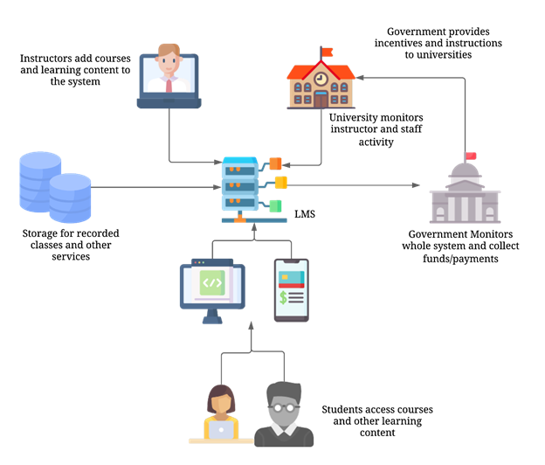

**Fig. 3.** Rich Picture of Envisioned Learning Management System

### **3.1.2 Process Diagrams**

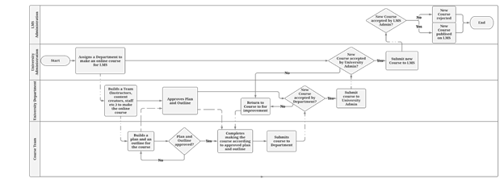

**Fig. 4.** Process diagram of Adding a new course in the LMS

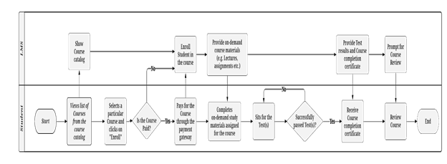

**Fig. 5.** Process Diagram of completing a course online by any Student

# **4 Problem Statement**

There are several problems prevailing in our higher education availing system for which the knowledge is not evenly distributed. Starting from primary education there are some institutions that are comparatively better. Better students get the opportunity to study in better institutions is more like an unwritten rule. To produce an army of skilled manpower this division in knowledge distribution will be a major hindrance. To cope up with the global challenge and FIR the youth needs to know-how will be the upcoming age and what should be necessary knowledge to strive better. The government has taken several steps to include ICT education and the use of ICT in secondary and higher secondary education levels. But in the case of tertiary education the prevalence of division mentioned would lead to a blunt manpower eventually which will lead to shattered economic condition.

**4.1 Stratification**

Universities and higher education institutions have a huge stock of knowledge, from professors, lecturers, and students. These knowledge and skills are only passed down to a small number of individuals in society. Therefore, big stratifications occur in education and status. If their knowledge and skills could be distributed among the rest of the crowd at minimal cost, the whole economy would rise.

Just by looking at the educational institutions in Bangladesh, we can see the difference in the quality of education. The system is stratified. Students at renowned universities get better opportunities to learn from the best teachers, their perspective towards the upcoming age is realistic, the adaptation of new technology is higher in them. There are many institutions in Bangladesh, providing higher education often the standard of education is not equal. Not getting a chance in renowned universities is more like a curse. Even in the case of getting a job, a university certificate matters. This stratification makes a lot of students suffer from inferior complexity and the mass youth are not being prepared to face the challenges.

**4.2 Inadequate Seats to Avail Higher Education**

The number of students completing higher secondary education and the number of available seats to provide higher education has a huge gap and the quality of education provided in all these institutions is stratified. As a result, a huge part of the youth is deprived of quality education, they are not being well equipped to face the challenges of the 21st Century.

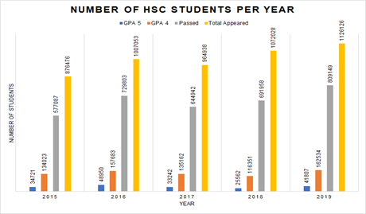

**Fig. 1.** Number of students getting GPA 5.0, GPA 4.0 and passing compared to the number of students appear in HSC Examination

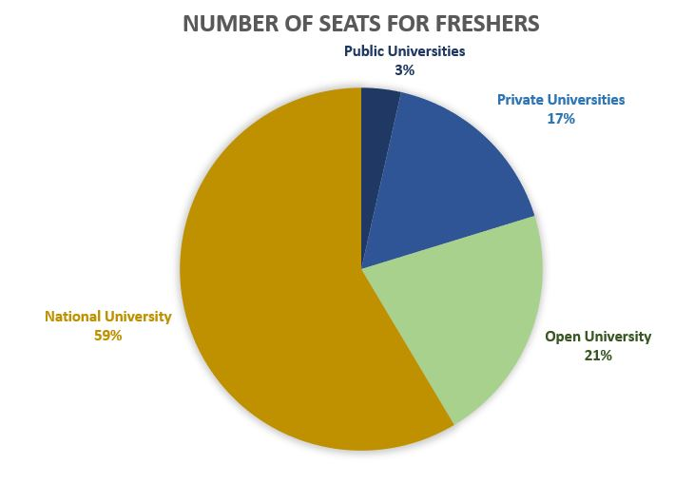

**Fig. 2.** Number of seats available for first year students in Public, Private, National and Open Universities of Bangladesh

**4.3 Communication Problem**

Moreover, the communication infrastructure of Bangladesh is still under development. Students must go through a great deal of hassle for being present in admission tests and Universities. The socio-economic structure is not that developed as a result parents go through hardship for bearing the living cost. Moreover, social constraints create a lot of obstacles for female students. These kinds of obstacles hinder many students from getting a higher education. With the development of the ICT sector in Bangladesh, these problems can be solved.

All these above-mentioned problems are going to create many unqualified human resources. It is also evident that only a few institutions provide quality education most of the time which are not also equally qualified to each other and the universities around the world. The upcoming challenge is global and the stratification in knowledge is going to make everyone suffer. Coming days are for working together, confronting the change together to make the world a better place. Therefore, the knowledge is equally significant for everybody to live a better standard of living irrespective of the background.

# **5 Proposed Solution**

An envisioned learning management system for higher education will include courses from different universities around the country, training courses, workshops, seminars by well-known persons with a very reasonable cost so that students can afford from anywhere anytime across the country according to their desire and demands will help to accomplish the initiative. Education will be barrier-free, there will be no restriction on gaining knowledge thus the youth of Bangladesh will be equipped with the knowledge to face the challenges of the 21st Century. It will also promote economic growth by contributing to public-private partnerships, the rapid growth of IT industries, research, and development. More youth will be involved in research and development.

The initiative will be taken to set up an ICT focused virtual university...throughout the country. This will not only accelerate the decentralization of quality ICT education but also ensure efficient utilization of available resources.

Objectives/Outcomes

* Central Learning Management System for Higher Education
* Students from all over the country avail their desired higher education
* Bring down the gaps of knowledge
* Give rise to qualified human resources
* Ensuring a quality education for all.

Deliverables

* User-friendly Learning Management System
* Personalized Dashboards for all teacher and students
* Inexpensive but top-level education
* Authorized certificate on completion of courses
* Need-based scholarship

**Planning**

The Following are planning activities that fall within the Pre-Development phase.

1. Feasibility Analysis
2. Project charter
3. Requirements analysis - SRS
4. Time and Budget estimation

**Functional Requirements**

The main functional requirements and high-level features required for the LMS are categorized under the following modules. Each feature or requirement has to be further broken down into its activities and tasks which can be grouped as the standard phases of SDLC i.e. Planning and data collection, Design, Development, Testing, Integration, and Deployment.

1. User Management module
   * Identity management and auth service - User identity Management, authentication & authorization middleware, login, registration, etc.
   * Developers, Staff, and Administration access - users who have specific privileges and access to certain services
   * University registration
   * Student registration
2. Course Management module
   * Course Catalog - store of all courses
   * Tracks/specialization service
   * Course enrollment service - Progress tracking of ongoing and finished courses
   * Course verification and validation service - the service responsible for verification/validation of new uploaded courses
   * Course forum - the forum for discussion and collaboration within a course
3. Classroom module
   * Recorded course classroom - allows students to access courses on demand, take notes, make comments, and connect with other students on forums
   * Live classroom - allows students to access live classes, take notes, make comments, and connect with other students on forums
4. Exam Management module
   * Exam Scheduling
   * Exam panel
5. Scholarship and Certification module
   * Results and Performance evaluation
   * Certificate generation and issuance
   * Scholarship Regulation
6. University Management module
   * University course scheduling service
   * Instructor allocation
   * university dashboard - shows the current state of the university on the LMS, its reports and notifications
   * university report generation
7. Student Management module
   * Student Homework & Assignment service
   * Student dashboard - assignments, records, certifications & notifications etc.
8. Payment processing module
   * Payment gateway integration
   * Revenue/Fund control panel
9. Monitoring and audit module
   * Administration Control panel - service for backend and privilege access to the platform
   * Monitoring report generation service

WBS

**Fig. 6.** Work Breakdown structure of activities need to be performed to develop the envisioned Learning Management System

# **6 Feasibility Analysis**

## **6.1 Economical Feasibility**

|  |  |  |  |  |  |  |  |  |  |  |  |  |  |  |  |  |  |  |  |  |  |  |  |  |  |  |  |  |
| --- | --- | --- | --- | --- | --- | --- | --- | --- | --- | --- | --- | --- | --- | --- | --- | --- | --- | --- | --- | --- | --- | --- | --- | --- | --- | --- | --- | --- |
| Activity ID | | Module | | Activity | Dependency | | Estimated workload units | | | Total Estimate Time (Man Days) | | | Time taken for task (Man day) | | | | | | | | | | | | | | | |
| Collecting & Validating Data | | | System Design & Architecting | | | UX/UI Design | | | Coding | | | Testing Unit, Integration, UAT | | Deployment/Implementation | |
| 1 | User Management module | | Identity management and auth service | | | 0 | | 10 | | | | 80 | | 10 | | | 10 | | | 20 | | | 20 | | | 10 | | 10 |
| 2 | User Management module | | Developers, Staff and Administration | | | 1 | | | 4 | | 32 | | 4 | | 4 | | | 8 | | | 8 | | | 4 | | | 4 | |
| 3 | User Management module | | University registration | | | 2 | | | 4 | | 32 | | 4 | | 4 | | | 8 | | | 8 | | | 4 | | | 4 | |
| 4 | User Management module | | Student registration | | | 3 | | | 4 | | 32 | | 4 | | 4 | | | 8 | | | 8 | | | 4 | | | 4 | |
| 5 | Course Management module | | Course Catalog | | | 4 | | | 6 | | 48 | | 4 | | 4 | | | 8 | | | 8 | | | 4 | | | 4 | |
| 6 | Course Management module | | Tracks/specialization service | | | 5 | | | 3 | | 24 | | 3 | | 3 | | | 6 | | | 6 | | | 3 | | | 3 | |
| 7 | Course Management module | | Course enrollment service | | | 6 | | | 3 | | 24 | | 3 | | 3 | | | 6 | | | 6 | | | 3 | | | 3 | |
| 8 | Course Management module | | Course verification and validation service | | | 7 | | | 3 | | 24 | | 3 | | 3 | | | 6 | | | 6 | | | 3 | | | 3 | |
| 9 | Course Management module | | Course forum | | | 8 | | | 4 | | 32 | | 4 | | 4 | | | 8 | | | 8 | | | 4 | | | 4 | |
| 10 | Classroom module | | Recorded course classroom | | | 9 | | | 10 | | 80 | | 10 | | 10 | | | 20 | | | 20 | | | 10 | | | 10 | |
| 11 | Classroom module | | Live classroom | | | 10 | | | 8 | | 64 | | 8 | | 8 | | | 16 | | | 16 | | | 8 | | | 8 | |
| 12 | Exam Management module | | Exam Scheduling | | | 11 | | | 7 | | 56 | | 7 | | 7 | | | 14 | | | 14 | | | 7 | | | 7 | |
| 13 | Exam Management module | | Exam panel | | | 12 | | | 10 | | 80 | | 10 | | 10 | | | 20 | | | 20 | | | 10 | | | 10 | |
| 14 | Scholarship and Certification module | | Results and Performance evaluation | | | 13 | | | 5 | | 40 | | 5 | | 5 | | | 10 | | | 10 | | | 15 | | | 5 | |
| 15 | Scholarship and Certification module | | Certificate generation and issuance | | | 14 | | | 5 | | 40 | | 5 | | 5 | | | 10 | | | 10 | | | 5 | | | 5 | |
| 16 | Scholarship and Certification module | | Scholarship Regulation | | | 15 | | | 5 | | 40 | | 5 | | 5 | | | 10 | | | 10 | | | 5 | | | 5 | |
| 17 | University Management module | | University course scheduling service | | | 16 | | | 8 | | 64 | | 8 | | 8 | | | 16 | | | 16 | | | 8 | | | 8 | |
| 18 | University Management module | | Instructor allocation | | | 17 | | | 3 | | 24 | | 3 | | 3 | | | 6 | | | 6 | | | 3 | | | 3 | |
| 19 | University Management module | | university dashboard | | | 18 | | | 6 | | 48 | | 6 | | 6 | | | 12 | | | 12 | | | 6 | | | 6 | |
| 20 | University Management module | | university report generation | | | 19 | | | 5 | | 40 | | 5 | | 5 | | | 10 | | | 10 | | | 5 | | | 5 | |
| 21 | Student Management module | | Student Homework & Assignment service | | | 20 | | | 4 | | 32 | | 4 | | 4 | | | 8 | | | 8 | | | 4 | | | 4 | |
| 22 | Student Management module | | Student Dashboard | | | 21 | | | 5 | | 40 | | 5 | | 5 | | | 10 | | | 10 | | | 5 | | | 5 | |
| 23 | Payment processing module | | Payment gateway integration | | | 22 | | | 8 | | 64 | | 8 | | 8 | | | 16 | | | 16 | | | 8 | | | 8 | |
| 24 | Payment processing module | | Revenue/Fund control panel | | | 23 | | | 6 | | 48 | | 6 | | 16 | | | 12 | | | 12 | | | 6 | | | 6 | |
| 25 | Monitoring and audit module | | Administration Control panel | | | 24 | | | 10 | | 80 | | 10 | | 10 | | | 20 | | | 20 | | | 10 | | | 10 | |
| 26 | Monitoring and audit module | | Monitoring report generation service | | | 25 | | | 8 | | 64 | | 8 | | 8 | | | 16 | | | 16 | | | 8 | | | 8 | |
|  |  |  |  |  |  |  |  |  |  |  |  |  |  |  |  |  |  |  |  |  |  |  |  |  |  |  |  |  |

Cost-Benefit Analysis

Cost

* LMS Development = $ X
* LMS Maintenance and operation = $ (10% of X) + β(N, X)
* Total University incentives = $ P
  + **Commission relief** i.e. no commission for first 2/<> years if you can make K/courses in a year
    - E.g. suppose a total of 10 universities, but only 5 hit the target.

If incentive per university is (p) = $ 1Mil

Total incentive, P = p * 5 = 5Mil

* + **Tax relief**
  + **Subsidy**

Q. What is the total cost of Government for the LMS in the first N (e.g. 10) years?

Q. What does that cost consist of?

Revenue

* A = # of unis
  + A’ = Growth rate per year
* B = # of courses per university
  + B’ = Growth rate per year
* C = number of students enrolled per course
  + C’ = Growth rate per year
* D = avg price per course = $20

At time t = 0,

Revenue = A * B * C * D

At t = 1,

Revenue = (A+A’) * (B+B’) * (C+C’) * D

At t = 2,

Revenue = (A+A’+A’) * (B+B’+B’) * (C+C’+C’) * D

At t = n,

Revenue = (A+n*A’) * (B+n*B’) * (C+n*C’) * D

Net Present Value Analysis

|  |  |  |  |  |  |  |  |
| --- | --- | --- | --- | --- | --- | --- | --- |
| Cash Flow Description | Year 0 | Year 1 | Year 2 | Year 3 | Year 4 | Year 5 | Year 6 |
| Cost | | | | | | | |
| Development Cost: | 197,120 |  |  |  |  |  |  |
| Operation and maintenance cost: |  | 20,000 | 21,000 | 22,000 | 23,000 | 24,000 | 25,000 |
| Discount Factors | 1.00 | .89 | .79 | .70 | .62 | .55 | .49 |
| Time-Adjusted Costs | 197,120 | 17,800 | 16,590 | 15,400 | 14,260 | 13,200 | 12,250 |
| Cumulative time-adjusted costs over lifetime: | 197,120 | 214,920 | 231,510 | 246,910 | 261,170 | 274,370 | 299,820 |
| Benefits | | | | | | | |
| Benefits derived from operation of new system: |  | 50,000 | 72,600 | 87,846 | 102,480 | 139,360 | 189,000 |
| Discount Factor | 1.00 | .89 | .79 | .70 | .62 | .55 | .49 |
| Time-Adjusted Benefits |  | 44,500 | 57,354 | 61,492 | 63,537 | 76,648 | 92,610 |
| Cumulative time-adjusted benefits over lifetime: |  | 44,500 | 101,854 | 163,346 | 226,883 | 303,531 | 396,141 |
| Cumulative lifetime time-adjusted (benefits - cost) | 197,120 | 170,420 | 129,656 | 83,564 | 34,287 | **29,161** | **96,321** |

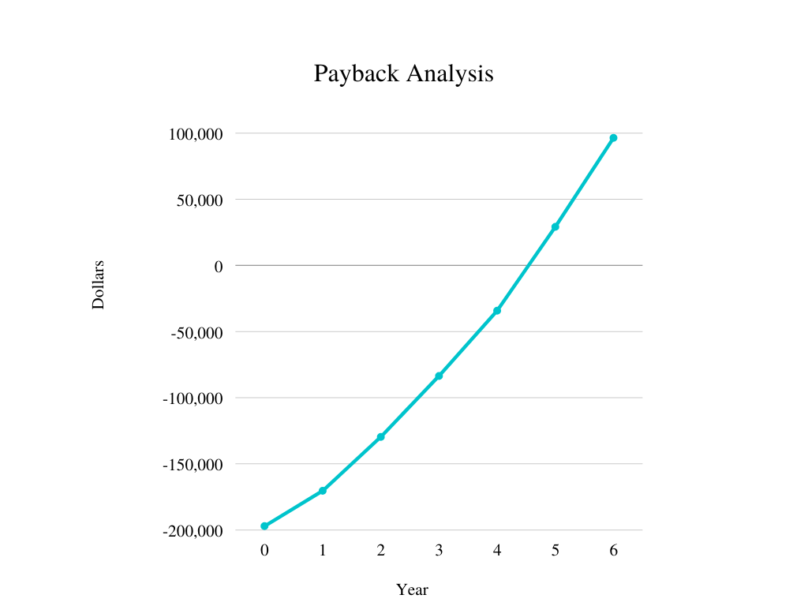

## 

## **6.2 Technical Feasibility**

**Swot Analysis**

|  |  |
| --- | --- |
| **Strengths** | **Weakness** |
| · Independence of access to time and place  · Impartiality  · Enhancing the individual and group participation.  · Exposure to Global standard of education | · Less feedback  · Cause social Isolation  · Lack of communication skill  · Cheating prevention  · Lacks face-to-face communication  · Limited to certain disciplines  · Lack of computer skill |
| **Opportunities** | **Threats** |
| · Enrollment of more  · Work-life Balance  · Time saving  · Cost efficient  · | · Threat to Uniqueness and consistency  · High implantation and maintenance cost  · Lack of technology and Infrastructure  · Security and authorization issues. |

Strengths

The major strength of E-learning is easy access in any place and time. End-users can undergo learning or teaching process at their place in convenient time and also it does not have any restriction of time. E-learning in higher education is molded with flexibility, Agility, Geographical liberation which in turn gives self-sufficiency to the students pursuing Higher education through E-learning. Then comes Equity, E-learning provides extensive customization of learning opportunities that suffice the need of students. It also provides access to higher education in all streams irrespective of circumstances with equal access and equal opportunities to all and fulfils the objective of the higher education system. Enhancing collaboration among the student group is one among the strengths of e-learning. Even though they are scattered geographically, but still connected via Voice and video Conference, virtual classes, individual and group chat with Instructor and with fellow students. E-learning helps to reduce the fretfulness among students due to fear of lagging behind. It also motivates through various assessments and tasks, instant feedback, which encourage the focus, performance, self-confidence, habit of life-long learning and reduce stress.

Weaknesses

E-learning also has few weaknesses in the learning and teaching process of higher education. The major difference between the traditional and E-learning is absence of an instructor, which causes deleterious effects on academic enhancement and personal development of the students. Lack of relationship and direct communication between the students and tutors and complete dependency on technology leads to isolation of learners or students. This has less frequent help of rapid development of technology which helps to interact and cooperate with the tutors. The tools and techniques used by e-learning leads to disparity among the training that improves the digital competence to training that helps to develop academic skills. Feedback may be inappropriate since they are unaware how the student took the assessment. The technological service provided. e-learning is irreconcilable with psychological factors that persist in the learning process. It is not necessary that all the learning content and methods need to be effective and E-learning is incompatible for practical courses in Higher education. E-learning provides information and training related to practical sessions, but the learner cannot test their performance or real-time experience rather than master in envisaging.

Opportunities

E-Learning - Opportunities Lot of opportunities are created on successful combination of education and technology. It improvises the learning capacity along with the opportunities. Student provided with internet facility has access to lot of training materials, journals, digital library, virtual training and conferences, etc. which in turn provide more relevant and updated information and equip the student as knowledgeable and efficient in the stream he chosen in the higher education E-learning or online education not only save time but also provide opportunity for work-life balance. It provides opportunity to pursue higher studies in spite of commitment which includes family, employment, etc. it helps to find new opportunity in the stream the employee is working with the help of online .Cost incurred in e-learning is relatively less when compared with traditional learning and lay emphasis on the financial aspects such as distribution cost for service provider and travel and other conveyance cost for the learners. Increased opportunity in service providers of digital learning, preparation of training materials, online tutors, etc due to increased demand for e-learning. It also includes increased market share and technological development, economic development training. Universities have only limited number seats, it cannot offer higher education to all graduates, on the other hand there are many students who cannot attend direct classes due to various reasons. Higher education through online learning or e-learning bridges the gap. The development in technology helps in the rapid growth of e-learning.

Threats

E-learning helps in the simplification of the learning process and boost up the speed of growth of higher education, but it has many restrictions and limitations while implementing it. Though technology has many positive effects at the same time it has negative impacts. To pursue higher education through e-learning, availability of computers and access to internet is mandatory, but availability of computers and access to internet connection to everybody is a bit impossible due to economic and geographic distribution in developing countries. Next to availability here comes the knowledge about the usage of computers and related technology. Due to lack of knowledge and awareness about the courses and services offered through e-learning, this method is not yet spread across the locations. e-learning has limitations like security and authorization, lack of scrutiny of students, poor and lower bandwidth, inadequate infrastructure, and many other technical problems. The transformation of traditional learning methods to e-learning and replacement of teachers might also cause psychological effects too. It includes resistance to change, unwillingness to use technology, lack of confidence, fear of the unknown, lack of control, cost incurred in implementation and training for instructors.

## **6.3 The Benefits**

The benefits of implementing the proposed system are discussed below, with respect to the stakeholders involved.

**Benefits to Universities**

* **Generate more revenue**

Universities can generate revenue through selling online courses. Digital learning content is highly scalable, as they can be created once and used many times. As a result, universities can expect to make good returns on investment in the long run.

* **Get incentives from the Government**

As well generating their revenue, universities can also be applicable to incentives from the government if they make regular quality courses and learning materials on the LMS. The incentives could be in many forms including tax incentives, subsidies etc.

* **Enhance Diversity**

The universities can get access to a wider range of students/audience in a platform that is online. This enables them to have a much diverse pool of students and alumni who could work to improve the operations of the university.

* **Collaborate with other universities**

Universities can share resources (e.g. editors, graphic designers, developers) with other universities, or collaborate with them. This has a net effect of producing better learning content.

**Benefits to Students**

* **Cheaper courses**

As courses are highly scalable and available online, they can be offered at much cheaper prices. This means that more students can get access to higher education.

* **On-demand learning**

Students get access to the learning content wherever and whenever they desire, as long as they are connected to the internet. This means that students can learn at their own pace instead of being overwhelmed with the pace of brick and mortar classes.

* **Customized learning programs**

Students do not necessarily have to go through a lengthy 3-6 year program just to graduate or learn about a subject. They can learn the topics that align with their goals and interests via courses that span from a few weeks to several months. With the freedom of choosing what and when to learn, students can explore their subjects of interest, as well as discover new topics that they resonate with.

NOTE: We acknowledge that students might not always make the best decisions by themselves. That is why, related or recommended courses could be grouped together to form degrees or specializations in order to guide students.

* **Get instant certification**

After completing each course, students will receive a certificate that they can share on their job profile or resume. This is a huge plus for students looking to get into the workforce as early as possible as they do not necessarily have to go through multiple years of study just to get certified.

* **Make more connections**

Students learning through an online LMS can benefit from the networking capabilities that come with such a platform. Students get to connect with other students and teachers from all around the nation - through forums, discussions, group projects etc.

**Benefits to the Government**

* **A stronger workforce**

By making higher education more accessible through the LMS, the amount of literate people in society would increase. This means that more and better skilled professionals like engineers, doctors, lawyers, researchers, entrepreneurs etc. can emerge. The result is a stronger workforce that the government can leverage.

* **Higher GDP**

More people with tertiary education and a stronger workforce, means that more people can contribute to society through their service/labor, paying taxes, sharing knowledge or implementing businesses etc. The net effect of this is higher gross domestic product (GDP).

* **Unified real-time audit and monitoring**

It is usually very difficult for the government to keep track of the latest university and education activities which is why the publicly available university data from UGC is always in a lag. Having a unified LMS will mean that the activities of universities can be recorded and analysed in real-time. e.g. the number of graduates in each subject, activities in universities etc.

**Benefits to the Citizens**

* **Easy access to higher education**

People who could not afford or did not have access to higher education - maybe due to responsibilities or age restrictions - can get its access now through the LMS.

* **More Jobs**

The development and operations of the LMS will provide access to numerous jobs to the citizens.

* **Better quality education**

As the universities are all making content on the same platform, competition will naturally occur. To differentiate their courses and attract more students, universities could offer better quality courses at cheaper prices to compete.

We acknowledge that the list of benefits discussed above is not exhaustive. Many other benefits could be discovered, or existing ones could be modified.

## **6.4 Quality Measurement**

The essential goal of educational quality processes is to ensure the quality of academic and education process development to meet its required purposes. E-learning is an effective learning practice using technological means to convey digital content with learning support and services that transfer knowledge from education's resources to the learners.Without applying the term "quality" on E-learning key elements, the process of education will fail. However, the difficulty lies in the term "quality" , which has various meanings from different perceptions and based on the understanding and objective of educational purposes, it seems to be extremely hard to easily define quality of education. The expected quality needs to rely much more on the objective and level of education itself, and then different quality standards may become applicable to measure achievements and extents of quality at different levels of education. Quality of e-learning can be understood as to provide high-quality learning opportunities enabling students to acquire better cognitive skills.

So,For measuring quality some quality criterias are developed here:

* In e-learning, the course material/content can consist of digital material. Thus the selection, production and adaptation of course content are of major importance to the quality of e-learning.
* The virtual environment is one of the most dynamic and rapidly changing features of e-learning, so systematic improvement and updating are needed on a continuous basis.
* Explicit strategy for communication, cooperation and interactivity according to educational needs, available technology and human resources
* Strategy for fair, flexible and pedagogically justified assessment.
* Implemented policy for dealing with copying, legal security and identification of students.
* Strategy for increasing the flexible features of education based on pedagogical considerations and students’ needs and demands.
* Strategy for student support including technical, administrative and social support on demand.
* Strategy for faculty support including technical, ICT and information competence support on demand.
* A strategy plan for e-learning with a visionary perspective, including research, quality assurance and development activities, and strategic local, national and international.
* A strategy for the reallocation of existing resources and the generation of new resources based on the specific needs of e-learning.
* There should be proper documentation for every module for future control of the quality.
* Time, cost progress should be controlled.

# **7 Limitations and Constraints**

This paper discussed the idea for the LMS solution on an abstract level and therefore, we acknowledge that it’s implementation could vary widely. Thorough research and analysis is required including calculation of risks, cost-benefit analysis and feasibility study. Only then, if the project seems feasible and beneficial, can design and development follow.

The Estimation was done on a very high level, and therefore it serves only as a crude approximation. Some points to keep in mind with the estimation are as follows:

* The modules are specified abstractly and will need a further detailed specification
* The main estimation unit “workload units” (equivalent time taken to develop a single UI frame/page) could vary widely from activity to activity, and role to role
* a fixed cost per man-hour is used for every role/task type, but man-hour pay varies from role to role and region to region

Detailed project estimation is required including in depth requirements analysis - where modules and tasks need to be further decomposed into smaller work packages.

# **8 Conclusion**

This paper addresses the problems relating to the low accessibility of higher education in Bangladesh, and in return proposes a solution - which would be a public LMS provided by the Government as an E-Service. Universities and higher education institutions will be incentivized to make courses and learning materials, which would be distributed easily and cheaply to the public through the platform.

By doing this, the proposed solution will make higher education more widely available.

With access to better education, the nation as a whole would have greater aggregate knowledge. This will open up good career opportunities for more people, giving them the chance to contribute to society by their labor, taxes, knowledge or business etc. In this way, the nation could establish a better quality of living as well as get one step closer to a Digital Bangladesh.

References and Bibliography

1. “Fourth Industrial Revolution.” *World Economic Forum*, www.weforum.org/focus/fourth-industrial-revolution.

2. Government of the People's Republic of Bangladesh, General Economics Division (GED) Planning Commission. *SEVENTH FIVE YEAR PLAN FY2016-FY2020*. 2015, [www.plancomm.gov.bd/site/files/2eb8022b-d4fb-42e1-a67d-67bccabd8fe9/-](http://www.plancomm.gov.bd/site/files/2eb8022b-d4fb-42e1-a67d-67bccabd8fe9/-).

3. Government of the People's Republic of Bangladesh, General Economics Division (GED) Planning Commission. “PERSPECTIVE PLAN OF BANGLADESH 2021-2041.” *The National Web Portal of Bangladesh*, 2020, www.plancomm.gov.bd/sites/default/files/files/plancomm.portal.gov.bd/files/10509d1f_aa05_4f93_9215_f81fcd233167/2020-08-31-16-08-8f1650eb12f9c273466583c165a315a4.pdf.

5. “Best Learning Management System (LMS) Software with Reviews & Comparison.” *SoftwareWorld*, 25 Sept. 2020, www.softwareworld.co/top-learning-management-system-software/.

6. The State of Queensland; Human Resources Branch, Corporate Services Division; “iLearn a Queensland Health Learning Management System.” *Queensland Health*, The State of Queensland, 29 Apr. 2016, [www.health.qld.gov.au/employment/professional-development/online-education](http://www.health.qld.gov.au/employment/professional-development/online-education).

7. “E-learning quality Aspects and criteria for evaluation of e-learning in higher education”Report2008:11R,http://www.diva-portal.org/smash/get/diva2:283764/FULLTEXT01.pdf.